LAB 1

Members:

* Huỳnh Ngọc Quang (SE181838)
* Nguyễn Văn Nhân (SE183547)
* Nguyễn Trung Nguyên (SE183195)

Objectives:

* Install and upgrade the CentOS system
* Install OpenSSH server

1. **Install and upgrade the CentOS system**

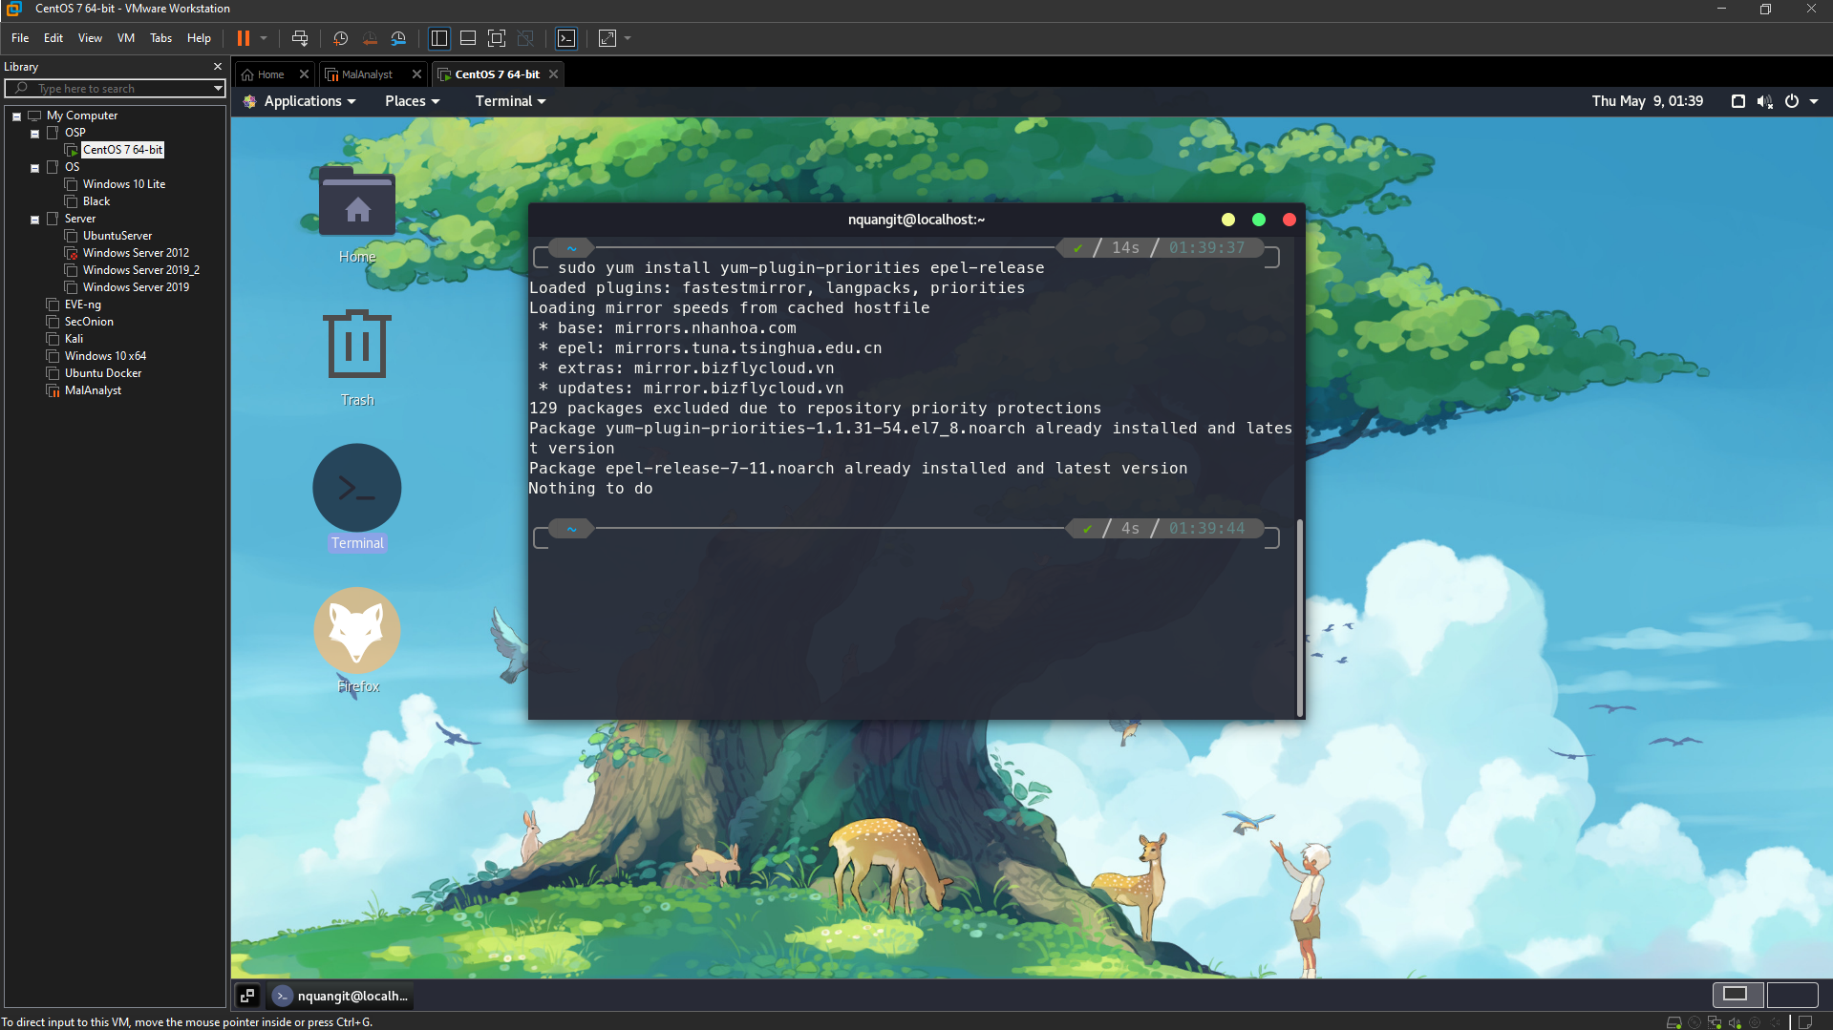

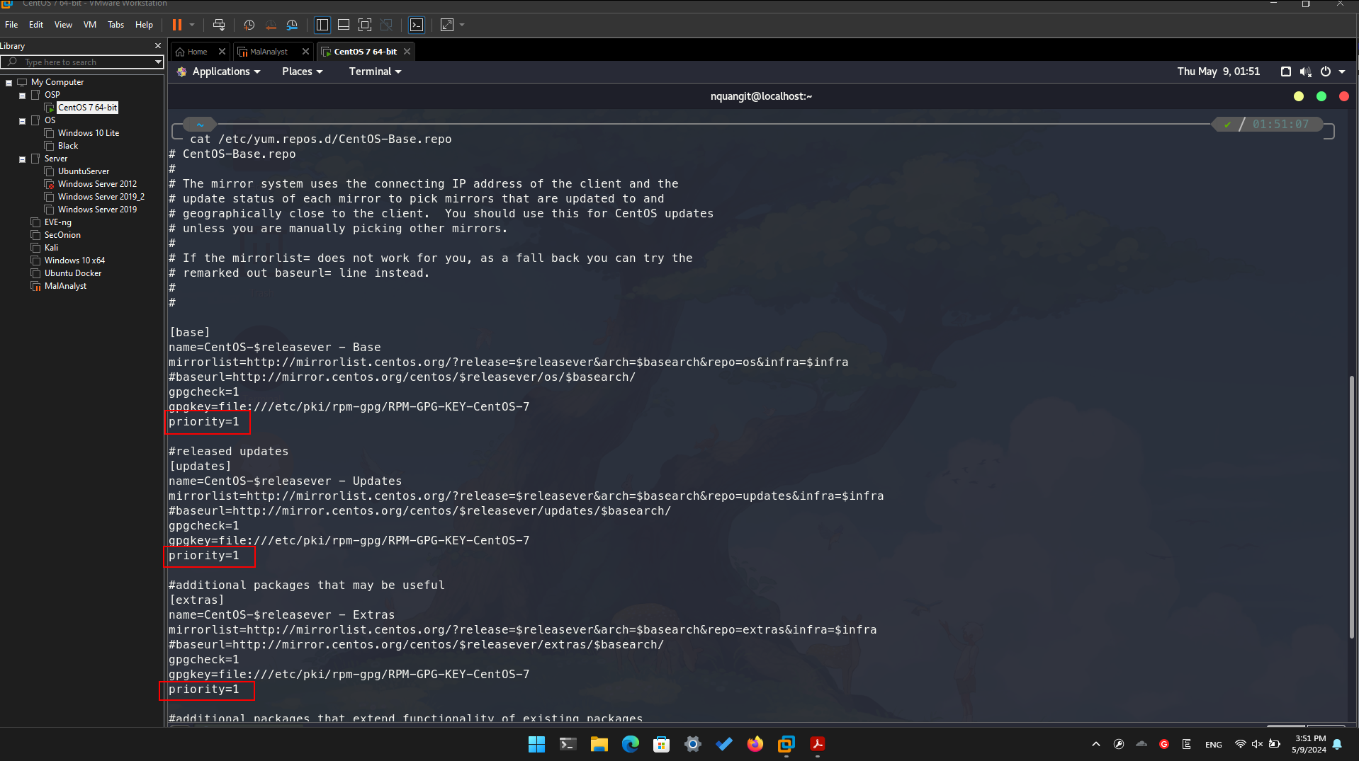

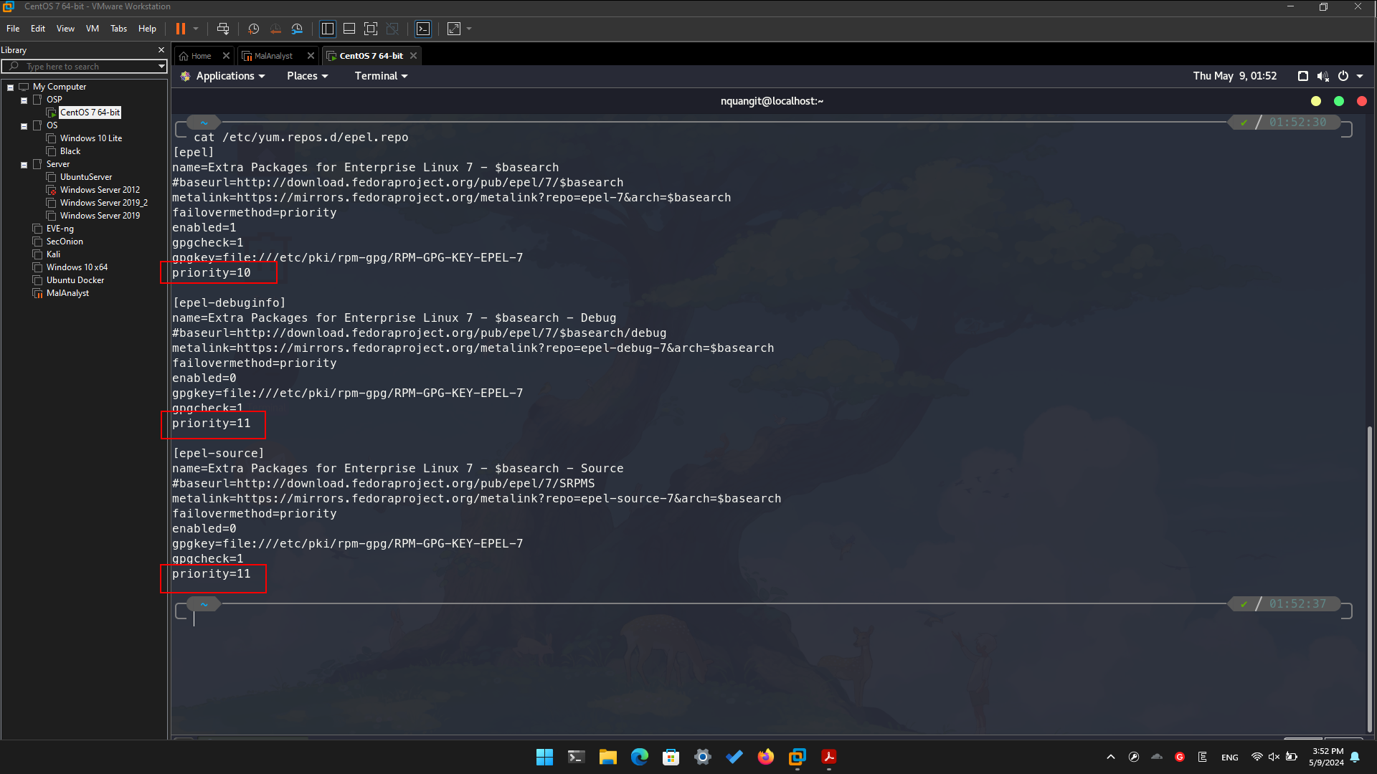

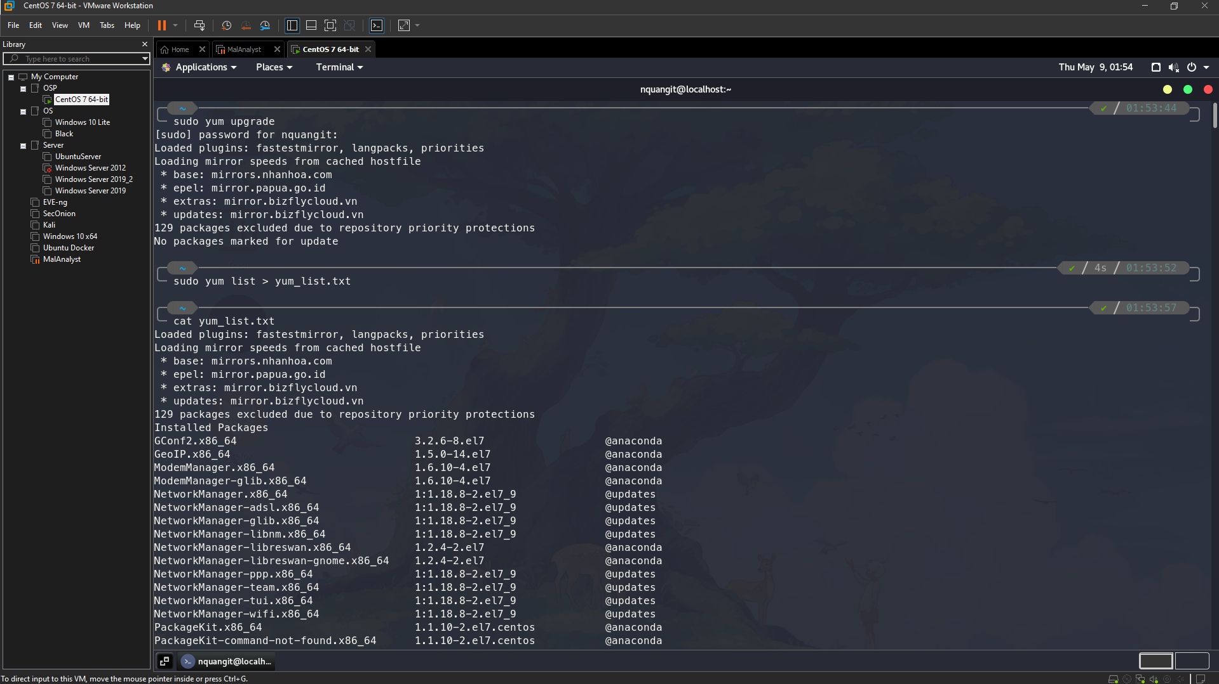

1. **Install OpenSSH server**

